Division _____________
Specification Section # _______________
Wall Mounted Stainless Steel Sani-Form™ (Angled Profile) Rail System
Part 1 General
Furnish 6” Face / 8-1/2” High (Angled Profile) Wall Mounted Stainless Steel Sani-Form™ Rail System for wall protection.

  - Quality Assurance
1.1.1 Manufacturer’s Qualifications: Obtain all materials from a single source manufacturer with at least five years’ experience in the fabrication of stainless-steel wall protection products.
1.1.2 Contractor’s Qualifications: Installation shall be performed by an approved contractor with not less than five years’ experience un wall protection systems. Installer shall have worked on projects of similar size and complexity and in facilities similar to this project.
1.1.3 Material Verification: Furnish the contractor with material test data to verify the alloy composition of the rail and components to be utilized in this project.
1.2 Warranty
Manufacturer should offer a limited lifetime warranty against material and manufacturing defects. Contractor should offer a one-year installation warranty.
1.3 Submittal
1.3.1 Submit at least one sample of railing, and one mounting bracket. Sample should be of sufficient size to demonstrate the salient features of the specification.
1.3.2 Samples submitted for consideration as product equals, should be submitted at least 10 days prior to bid date.
1.3.3 Submit Manufacturer’s printed Product Data Sheet for each product in this specification.
1.3.4 Submit Detail Drawings to include mounting and fastener options.
1.4 Field Conditions, Handling and Storage
1.4.1 A representative of the manufacturer shall visit the job site prior to obtaining field dimensions and/or installation, to evaluate the site conditions and report to the site supervisor and conditions that prohibit the initiation of the measurements and/or installation of the Sani-Form™ rail system.
1.4.2 Material delivered to the job site should be in unopened factory packaging.
1.4.3 Store materials in a climate-controlled environment.
1.4.4 Ensure all products delivered are the products listed in this specification.

Life Science Products, Inc Page 1 of 3 Rev. #312023
124 Speer Road Printed 3/1/23
Chestertown, MD 21620
Part 2 Products

2.1 Manufacturers
2.1.1 Acceptable Manufacturer:
Life Science Products, Inc.
124 Speer Road
Chestertown, MD 21620
Telephone: 800-638-9874 email: info@lspinc.com
2.1.2 Substitutions: Not Permitted.
2.1.3 Provide wall mounted rail from a single manufacturer.

2.2 Rail and Mounting Brackets:
2.2.1 Rail Shall have 6” (152.4mm) Face, 8-1/2” (215.9mm) High x 2” (50.8mm) Deep, with Angled Profile. 16 GA (.063” – 1.60mm) 304 or 316L Alloy Stainless Steel with a #4 Polish, supplied in maximum lengths of 10’-0” (3048mm). Material specifications shall conform to ASTM A-276.
2.2.2 Rail Mounting Brackets shall be 18 GA (.048” – 1.22mm) 304 or 316L Stainless Steel – Mill Finish. Mounting Tabs and Mounting Holes factory formed and drilled.
2.2.3 Angled Returns back to wall shall be Welded, Ground & Polished to Match Rail.
2.2.4 Rail shall not have continuous inside and outside corners.
2.2.5 Each rail section shall be marked with its own unique identification number on the back side of the rail, which will match the numbered section on the installation drawings. Plans must be maintained on file with the manufacturer for future reference.
2.2.6 Railing to be safely packaged to minimize scratches and packed in plywood crates for shipping to the site.

Part 3 Execution

3.1 Field Measurements
3.1.1 Prior to taking field measurements, all permanent walls and door bucks must be in place. All wall cutouts such as electrical panels, fire extinguishers, etc. Must be completed. Locations of cover plates should be installed to avoid being covered and/or obstructed by Sani-Form™ railings.
3.1.2 Field measurements must be taken within an 1/8” tolerance.
3.2 Site Exam
3.2.1 Ensure all site finishing steps are complete, including painting and coatings.
3.2.2 Wall shall be clean and free from dirt, grease, debris and moisture.
3.3 Fabrication
3.3.1 Fabrication tolerance shall be to the nearest 1/8”
3.3.2 Mounting Brackets should be placed no greater than 32” (812.8mm) apart.

Life Science Products, Inc. Page 2 of 3 Rev. #312023
124 Speer Road Printed 3/1/23
Chestertown, MD 21620

Sample Detail and Parts List
- Wall Mounted Stainless Steel Sani-Form™ Rail
- Stainless Steel Angled Wall Return – 304 Alloy w/#4 Polish
- Stainless Steel Mounting Bracket – 304 Alloy w/ Mill Finish

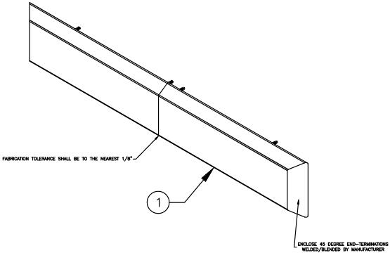
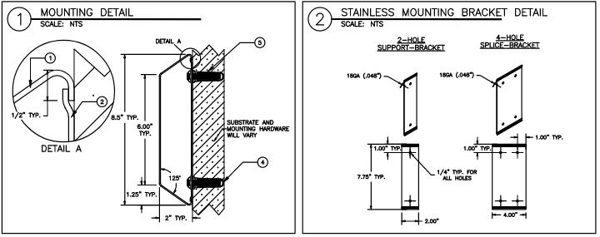

Life Science Products, Inc. Page 2 of 3 Rev. #312023
124 Speer Road Printed 3/1/23
Chestertown, MD 21620

