Division _____________
Specification Section # _______________
Floor or Wall Mounted 1.5” O.D. Stainless Steel San-Lever™ Tube Rail System
Part 1 General
Furnish 1.5” O.D. Floor or Wall Mounted Stainless Steel Sani-Lever™ Rail System for wall protection or pedestrian handrails as described in this Specification.

  - Quality Assurance
1.1.1 Manufacturer’s Qualifications: Obtain all materials from a single source manufacturer with at least five years’ experience in the fabrication of stainless steel wall protection products.
1.1.2 Contractor’s Qualifications: Installation shall be performed by an approved contractor with not less than five years’ experience un wall protection systems. Installer shall have worked on projects of similar size and complexity and in facilities similar to this project.
1.1.3 Material Verification: Furnish the contractor with material test data to verify the allo composition of the rail and components to be utilized in this project.
1.2 Warranty
Manufacturer should offer a limited lifetime warranty against material and manufacturing defects. Contractor should offer a one year installation warranty.
1.3 Submittal
1.3.1 Submit at least one sample of railing, and one mounting bracket. Sample should be of sufficient size to demonstrate the salient features of the specification.
1.3.2 Samples submitted for consideration as product equals, should be submitted at least 10 days prior to bid date.
1.3.3 Submit Manufacturer’s printed Product Data Sheet for each product in this specification.
1.3.4 Submit Detail Drawings to include mounting and fastener options.
1.4 Field Conditions, Handling and Storage
1.4.1 A representative of the manufacturer shall visit the job site prior to obtaining field dimensions and/or installation, to evaluate the site conditions and report to the site supervisor and conditions that prohibit the initiation of the measurements and/or installation of the Sani-Lever™ rail system.
1.4.2 Material delivered to the job site should be in unopened factory packaging.
1.4.3 Store materials in a climate-controlled environment.
1.4.4 Ensure all products delivered are the products listed in this specification.

Life Science Products, Inc Page 1 of 3 Rev. #112522
124 Speer Road Printed 12/1/22
Chestertown, MD 21620

Part 2 Products

2.1 Manufacturers
2.1.1 Acceptable Manufacturer:
Life Science Products, Inc.
124 Speer Road
Chestertown, MD 21620
Telephone: 800-638-9874 email: info@lspinc.com
2.1.2 Substitutions: Not Permitted.
2.1.3 Provide all floor and wall mounted rail from a single manufacturer.

2.2 Rail and Mounting Brackets:
2.2.1 Material shall be 1.5” O.D.(38.1mm) 304 or 316L Alloy Stainless Steel Tube with a #4 Polish and an 18 GA (.0478”) wall, supplied in maximum lengths of 12’ (3,657.6mm). Material specifications shall conform to ASTM A-276. The brackets used for mounting the rail be 304 or 316L Stainless Steel with a #4 Polish. Rail will not have continuous inside and outside corners.
2.2.2 Each rail section shall be marked with its own unique identification number on the inside of the bracket, which will match the numbered section on the installation drawings. Plans must be maintained on file with the manufacturer for future reference.
2.2.3 Railing to be safety packaged to minimize scratches and packed in plywood crates for shipping to the site.
2.2.4 Floor and Wall Mounting Brackets shall be fabricated from cast stainless steel.
2.2.5 Returns, Inside Corners and Outside Corners shall be a stainless steel and finish to match the tube rail.

Part 3 Execution

3.1 Field Measurements
3.1.1 Prior to taking field measurements, all permanent walls and door bucks must be in place. All wall cutouts such as electrical panels, fire extinguishers, et. Must be completed. Locations of cover plates should be installed to avoid being covered and/or obstructed by Sani-Lever™ railings.
3.1.2 Field measurements must be taken within an 1/8” tolerance.
3.2 Site Exam
3.2.1 Ensure all site finishing steps are complete. Including painting and coatings.
3.2.2 Floor and/or Wall shall be clean and free from dirt, grease, debris or moisture.
3.3 Fabrication
3.3.1 Fabrication tolerance shall be to the nearest 1/8”
3.3.2 Mounting Brackets should be placed no greater than 32” (812.8mm) apart.

Life Science Products, Inc. Page 2 of 3 Rev. #112522
124 Speer Road Printed 12/1/22
Chestertown, MD 21620

Sample Detail and Parts List

- Floor Mounted Stainless Steel Sani-Lever™ Rail – 1.5” x 18GA Wall 304 Alloy w/#4 Polish
- Stainless Steel Radius Wall Return – 304 Alloy w/#4 Polish
- Stainless Steel Mounting Bracket – 304 Alloy w/#4 Polish
- “Inner” Aluminum Splice Sleeve – 1-3/8” DIA. 6061 Alloy (Set w/Epoxy in Field)
- Construction Grade Adhesive - Loctite – PL 8X Premium Fast Grab Polyurethane Recommended or per Architectural Specification
- 10-32 x 8mm Stainless Steel Set Screw

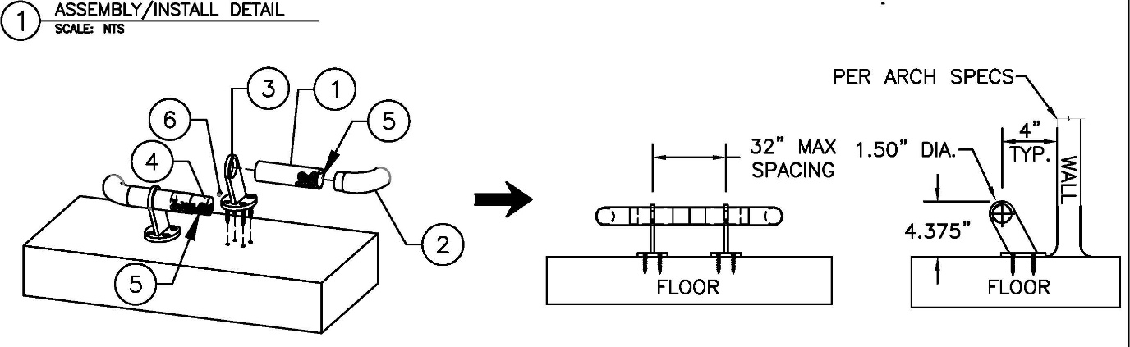

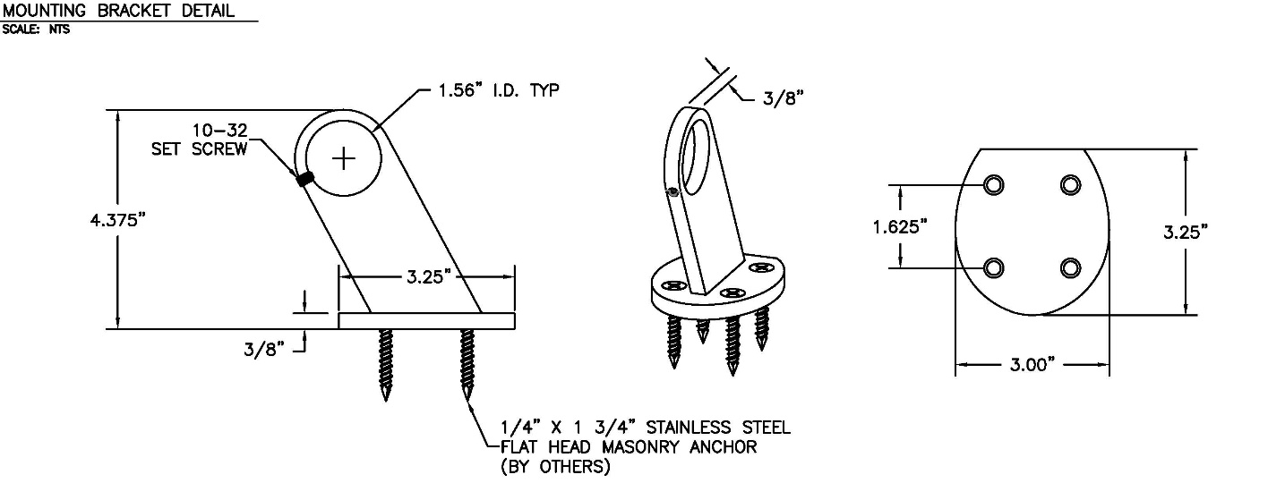

Life Science Products, Inc. Page 2 of 3 Rev. #112522
124 Speer Road Printed 12/1/22
Chestertown, MD 21620

